**SRIB Internship Report**

**Streamlined Bank Account Integration for Samsung Wallet**

**Intern:** T. Satya Sai Shyam Sundar

**Mentor:** Krishna Praveen R

**Reporting Manager:** Bipin Nanasaheb Patil

**Date:** 13/05/24 – 13/07/24

**Executive Summary**

This report details the development of a system to simplify the process of adding bank accounts to Samsung Wallet. The project aimed to enhance user experience by reducing manual efforts and streamlining the integration process. Three complementary components were developed:

* **Bank Application:** Provides a user-friendly interface for login, account management, and initiating the integration process with Samsung Wallet.
* **Samsung Wallet Application:** Enables users to manage existing wallet accounts, add new accounts, and receive notifications regarding account addition status.
* **Browser Extension:** Integrates seamlessly with online net banking platforms, allowing users to directly add accounts to their Samsung Wallet through a secure login process.

**1. Introduction**

This internship focused on developing a user-centric solution to streamline bank account integration with Samsung Wallet. The traditional process often involves manual data entry and can be cumbersome. This project aimed to address this challenge by creating a more intuitive and user-friendly experience.

**2. Use Case:**

**Use Case 1: Seamless Bank Account Integration**

* **User Login and Account Management:** Users can log in to their existing bank accounts or register for new accounts within the bank application. The "Accounts" page displays a list of all linked accounts, with clear visual representations of each bank (consider using bank logos or icons for better identification).
* **Initiating Wallet Integration:** Clicking on a specific account leads to an "Account Summary" page showcasing recent transactions. An "Add to Wallet" button, prominently displayed and clearly labelled, initiates the integration process.
* **Launching Samsung Wallet Application:** Upon clicking "Add to Wallet," the Samsung Wallet application launches automatically, establishing a seamless connection between the two applications.
* **Adding Account Through Wallet Application:** Manage existing accounts and add new accounts through this.

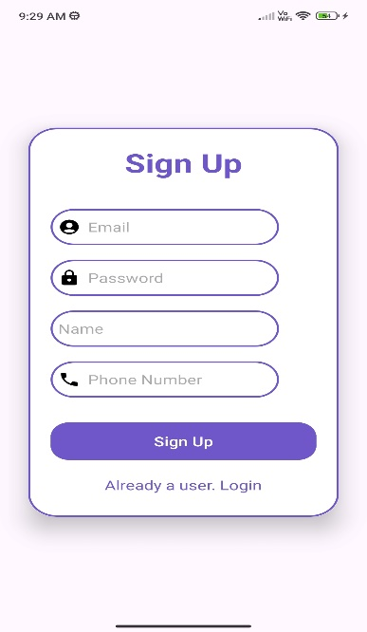 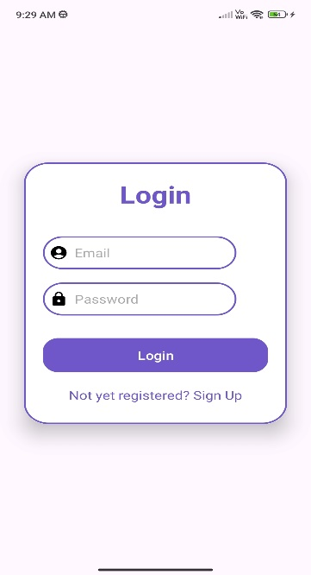 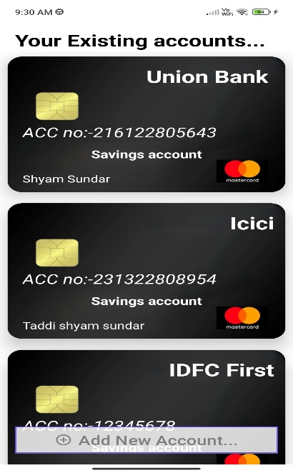

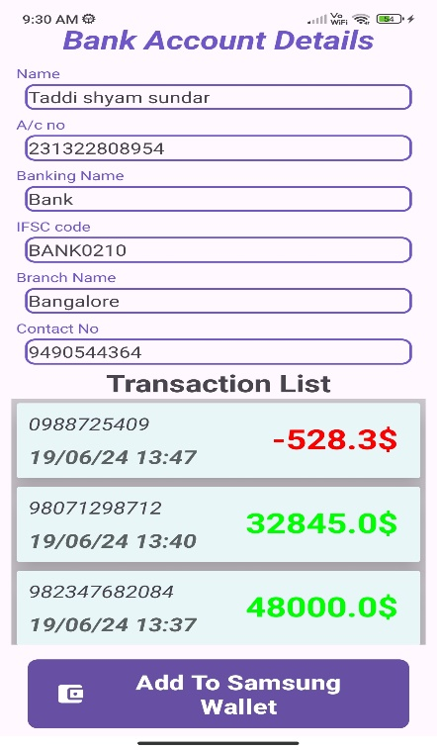 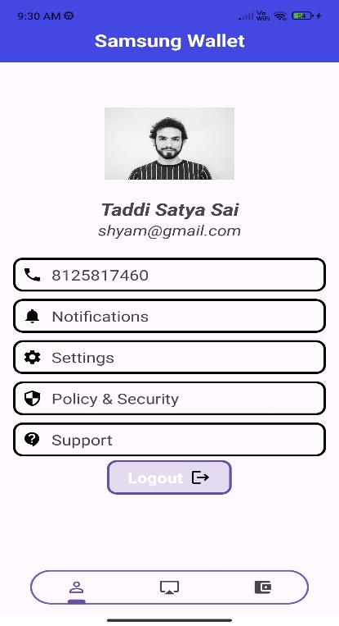 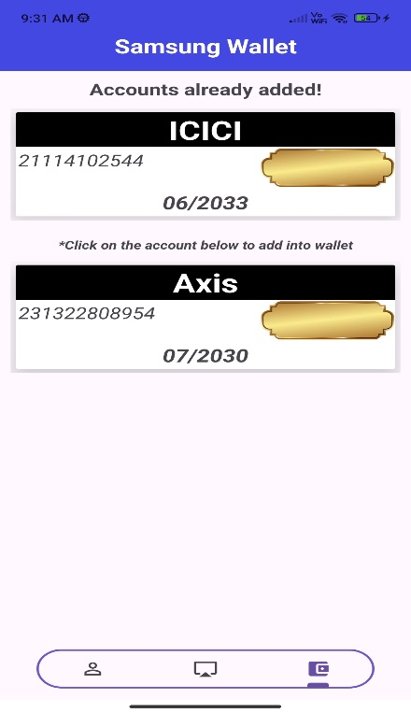

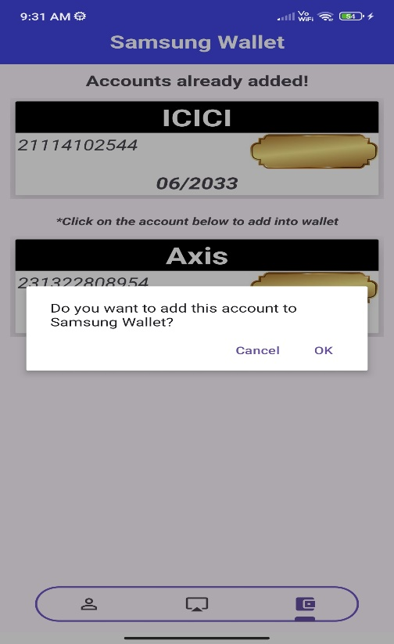

*Clicking ok completes addition of account

**Use Case 2: Integration with Backend Server**

* **Similar Flow up to Add to Wallet:** This use case follows the same steps as Use Case 1 until the "Add to Wallet" button is clicked.
* **Backend Server Communication:** Clicking the button triggers a communication with a secure backend server to initiate the account addition process. Encrypted communication protocols ensure the secure transmission of user credentials and account information.
* **Work in Progress Notification:** The Samsung Wallet application displays a "Work in Progress" message, informing the user that the account addition is being processed.
* **Wallet Notification and Account Addition:** Upon successful account addition, the user receives a notification within the Samsung Wallet application, and the account becomes accessible within the wallet, allowing users to manage their finances conveniently.

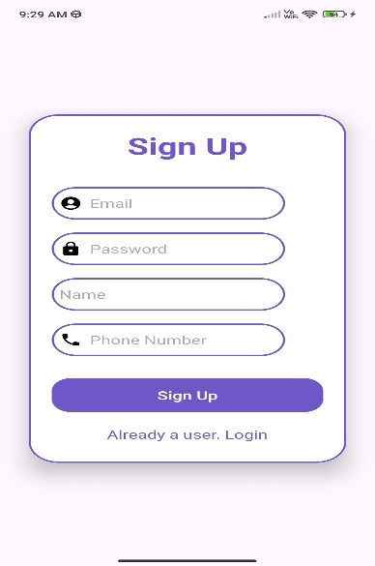 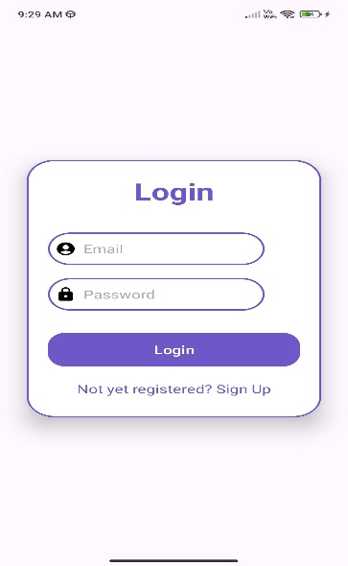 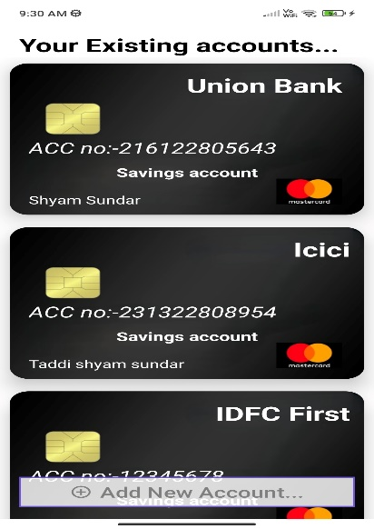

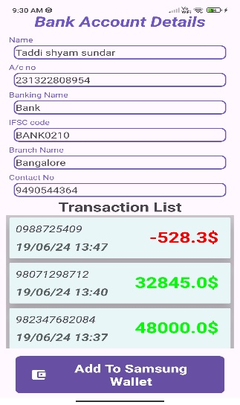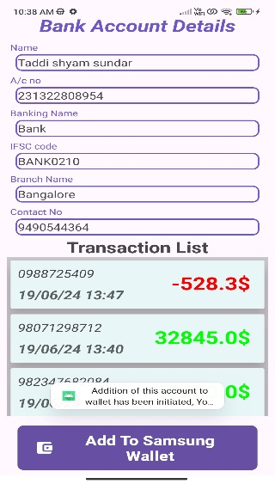 *Addition of account has been initiated through backend server call.

**Use Case 3: Browser Extension for Online Banking Integration**

* **Seamless Login with Samsung ID:** While using online net banking through a browser, users can open the browser extension and log in securely using their Samsung email ID and password. This login remains valid for 24 hours for convenient access and a logout button for manual logout.
* **Direct Account Integration:** The extension features an "Add to Wallet" button. Clicking this button initiates a secure backend communication process.
* **Secure Account Addition:** The backend server ensures the chosen account is seamlessly added to the user's Samsung Wallet.

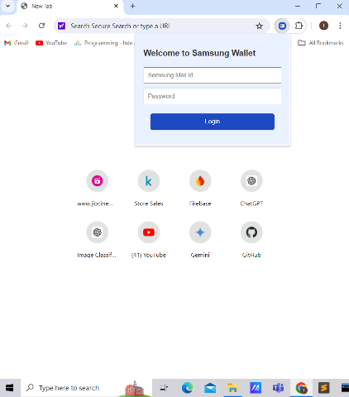

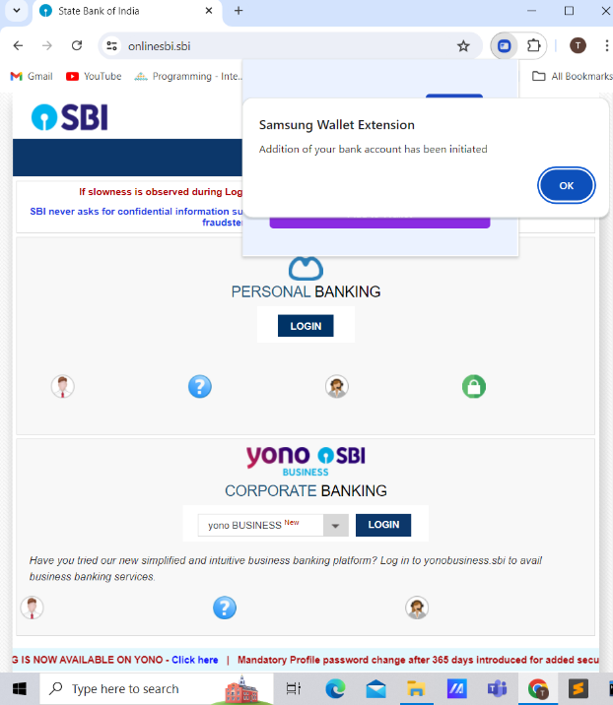

*Your addition of bank account to wallet has been initiated in the backend through API call

**3. Development Tools and Technologies**

* **Bank and Samsung Wallet Applications:** Developed using Android Studio, leveraging Java and XML for a native Android experience.
* **Browser Extension:** Developed using a combination of web development technologies, including JSON, HTML, CSS, and JavaScript, for seamless browser integration.

**4. Results and Discussion**

The developed system successfully achieves its objective of streamlining bank account integration with Samsung Wallet. By creating dedicated applications and a browser extension, the project offers users a user-friendly and efficient experience:

* **Reduced Manual Efforts:** Users no longer need to manually enter extensive account details during the integration process.
* **Enhanced Security:** Secure login processes, encrypted communication protocols, and backend server validation ensure the safety of user credentials and financial information.
* **Improved User Experience:** Intuitive interfaces, clear labelling, and notification systems provide a smooth and convenient way to manage bank accounts within Samsung Wallet.

**5. Conclusion**

This internship project has successfully demonstrated the feasibility of creating a user-centric solution for integrating bank accounts with Samsung Wallet. The developed system offers significant benefits by reducing manual efforts, enhancing security, and improving the overall user experience. While the current implementation serves as a solid foundation, future enhancements could explore features like multi-factor authentication and integration with a wider range of bank applications.

In conclusion, I express my sincere gratitude to SRIB, Krishna Praveen sir and Bipin sir for providing this valuable learning experience.

**6. References :**

* [**Installation and setup of Android studio**](https://developer.android.com/studio)
* [**Basic Application development**](https://developer.android.com/get-started/overview)
* [**Connection and usage of google firebase**](https://developer.android.com/studio/write/firebase)
* [**Login and signup Tutorials**](https://androidknowledge.com/login-signup-android-firebase/)
* [**GFG for some of the functional applications in application**](https://www.geeksforgeeks.org/how-to-populate-recyclerview-with-firebase-data-using-firebaseui-in-android-studio/)
* [**Web Development resources**](https://web.dev/)
* [**Chrome extension documentation**](https://developer.chrome.com/docs/extensions)
* [**Browser extension complete guide**](https://developer.mozilla.org/en-US/docs/Mozilla/Add-ons/WebExtensions)

**Thank You!**